EXPERIMENT- 14

Implementation of PPP using Packet Tracer

By

**Madhurya Mozumder (RA1911028010036)**

Under the guidance of

**Mrs. P. Visalakshi**

*In partial fulfilment for the course*

Of

**18CSC302J- COMPUTER NETWORKS**



**FACULTY OF ENGINEERING AND TECHNOLOGY**

**SRM ISNTITUTE OF SCEINCE AND TECHNOLOGY**

Kattankulathur, Chengalpattu District

November 2021

**ABSTRACT:** PPP is a WAN protocol that works at layer 2 by encapsulating frames for transmission over a variety of physical links such as serial cables, cell phones, fiber optic cable among others. it offers many more features as compared to HDLC and it is an open standard. Some of the features that it offers which are not available in HDLC include:

* Link quality management which is a way to monitor the quality of a link in PPP. When PPP detects too many errors on a link, the link is shut down.
* Authentication using PAP and/or CHAP

PPP operation is made using three parameters:

* Encapsulation of frames using HDLC protocol
* LCP (Link Control Protocol) for establishment, configuration and testing of the link
* NCP (Network Control Protocols) to negotiate the different layer 3 protocols.

**AIM:** To implement PPP Configuration using Cisco Packet Tracer.

**Procedure:** Create the setup as shown in the following figure and configure everything according to it.

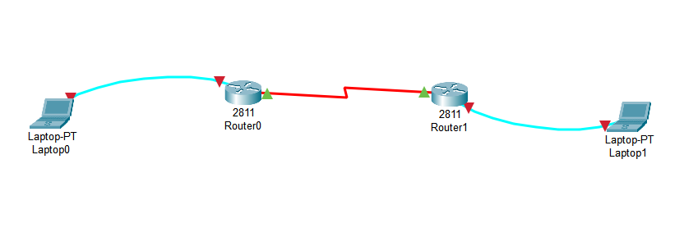

Go to the physical tab of each router, turn it off and place WIC-1T in its place and then switch the router on.

**1. Use the connected laptops to find the DCE and DTE routers**

The **show controllers <serial interface>** command is used to determine which side of the cable is the DCE side.

In this example, Router-A is the DTE side, and Router-B is the DCE side (DCE V.35, clock rate set).

**Router-A#show controllers serial 0/3/0**

**Interface Serial0/3/0**

**Hardware is PowerQUICC MPC860**

**DTE V.35 TX and RX clocks detected**

**Router-B#show controllers serial 0/3/0**

**Interface Serial0/3/0**

**Hardware is PowerQUICC MPC860**

**DCE V.35, clock rate 2000000**

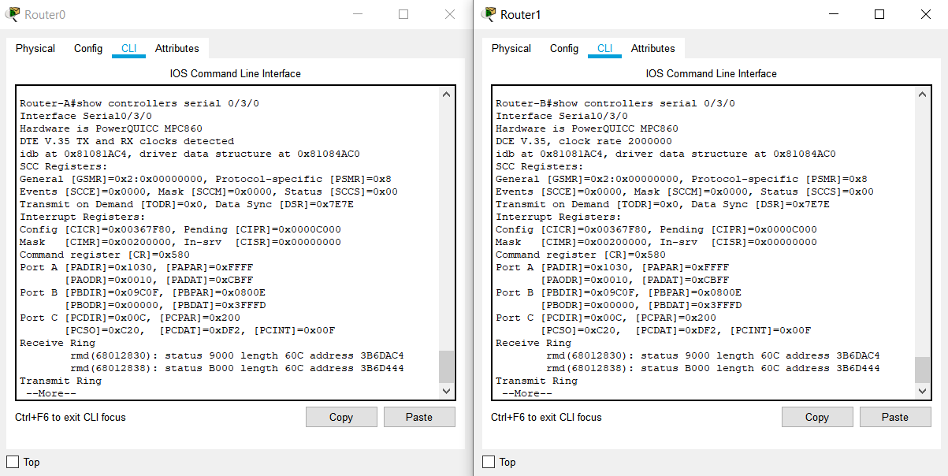



**2. Configure the routers with the following parameters**

Router-B being the DCE, clock rate has to be configured on Router-B serial 0/3/0 interface

**Router-B(config)#interface serial 0/3/0**

**Router-B(config-if)#clock rate 250000**

Then, configure PPP encapsulation and IP address on Router-B serial 0/3/0 interface.

The **encapsulation PPP** configures PPP protocol on the serial interface.

Router-B being the DCE side of the serial link, the 192.168.10.5/30 IP address is configured on the Router-B serial 0/3/0 interface. Don’t forget to enable the interface with a **no shutdown** command.

**Router-B(config)#interface serial 0/3/0**

**Router-B(config-if)#encapsulation ppp**

**Router-B(config-if)#ip address 192.168.10.5 255.255.255.252**

**Router-B(config-if)#no shutdown**

Finally, configure PPP encapsulation and IP address on Router-A serial 0/3/0 interface. The link becomes up as both routers are correctly configured.

**Router-A(config)#interface serial 0/3/0**

**Router-A(config-if)#encapsulation ppp**

**Router-A(config-if)#ip address 192.168.10.6 255.255.255.252**

**Router-A(config-if)#no shutdown**

**%LINK-5-CHANGED: Interface Serial0/0/0, changed state to up**

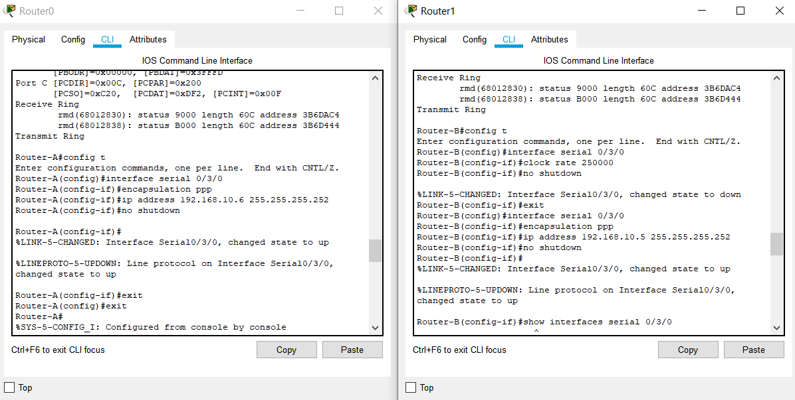



The show interfaces serial 0/3/0 confirms that PPP encapsulation is enabled on the interface: *Encapsulation PPP, loopback not set, keepalive set (10 sec)*

**Router-B#show interfaces serial 0/3/0**

**Serial0/0/0 is up, line protocol is up (connected)**

**Hardware is HD64570**

**Internet address is 192.168.10.5/30**

**MTU 1500 bytes, BW 1544 Kbit, DLY 20000 usec,**

**reliability 255/255, txload 1/255, rxload 1/255**

**Encapsulation PPP, loopback not set, keepalive set (10 sec)**

**Last input never, output never, output hang never**

**[...]**

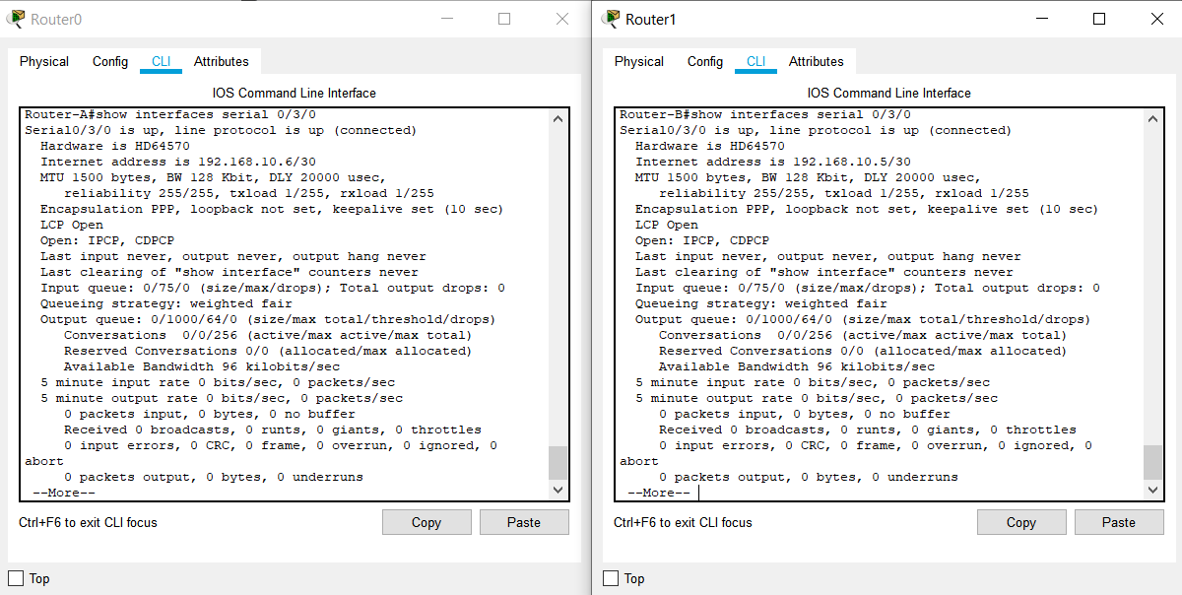



**3. Check IP connectivity between the two routers using the ping command.**

Issue a ping from Router-A to Router-B to test network connectivity between the two routers.

**Router-A#ping 192.168.10.5**

**Type escape sequence to abort.**

**Sending 5, 100-byte ICMP Echos to 192.168.10.5, timeout is 2 seconds:**

**!!!!!**

**Success rate is 100 percent (5/5), round-trip min/avg/max = 3/3/4 ms**

**Router-B#ping 192.168.10.6**

**Type escape sequence to abort.**

**Sending 5, 100-byte ICMP Echos to 192.168.10.6, timeout is 2 seconds:**

**!!!!!**

**Success rate is 100 percent (5/5), round-trip min/avg/max = 1/8/22 ms**

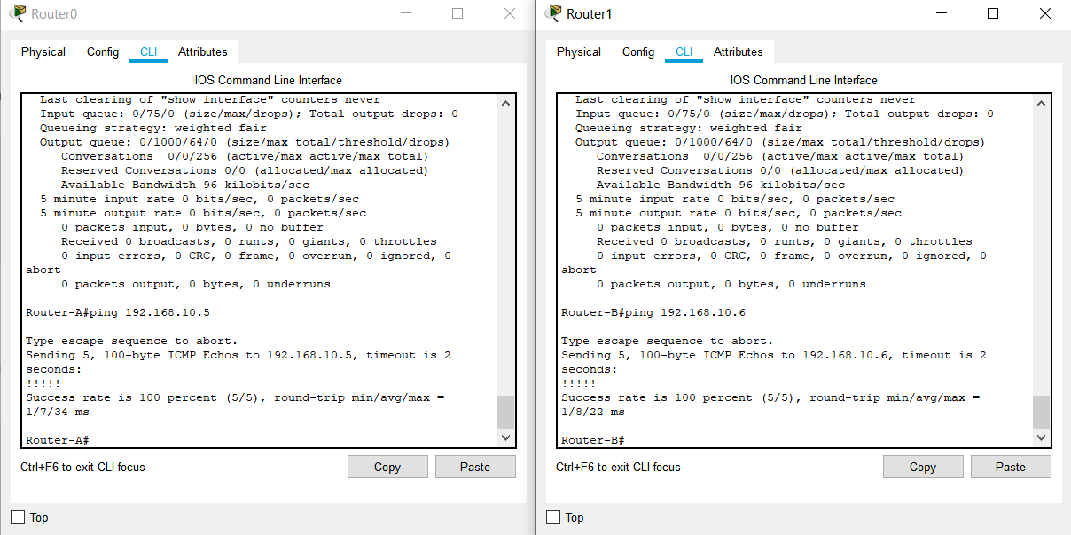



**Architecture and Implementation:**

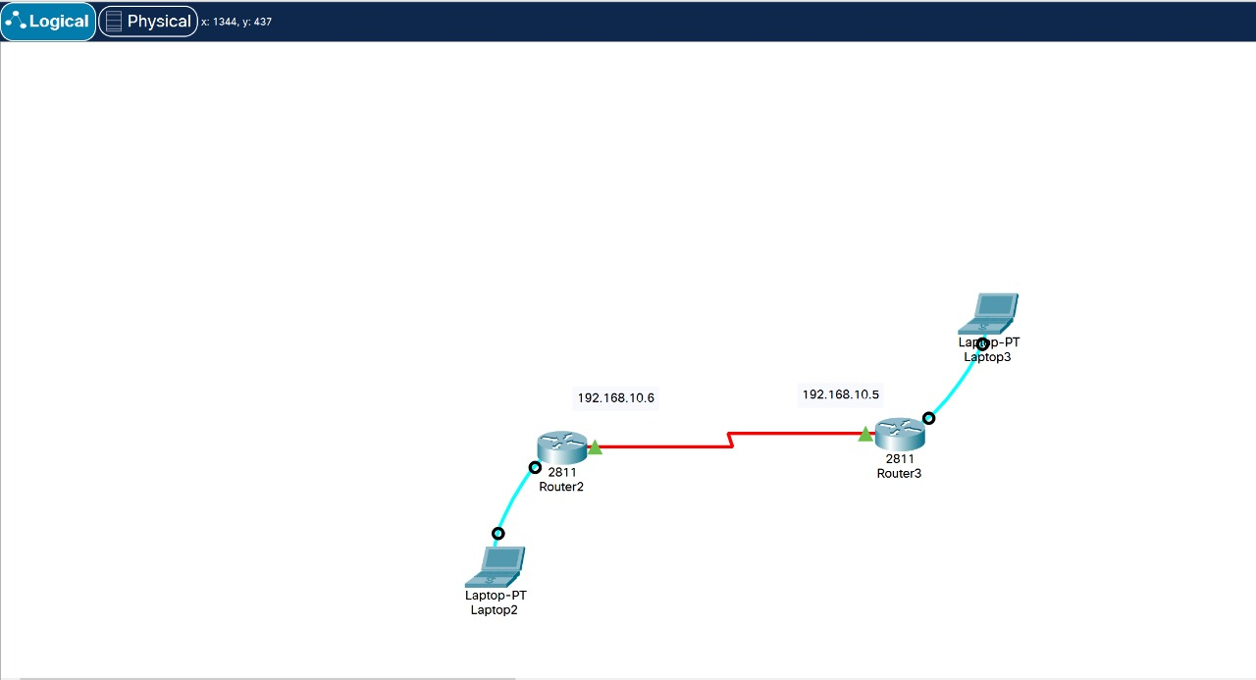

**RESULT:** PPP Configuration is successfully implemented and demonstrated.